PAGE1/5

SPECIFICATION

PRODUCT TYPE： OF9745P-2A303
Engineering No.:
Customer Material Code：
Customer Type:

DSND BY
CHKD BY
APRVD BY

PAGE 2/5
1 | Name：Omnidirectional Electret Condenser Microphone (Foil Electret Type)
2 | TYPE：OF9745P-2A303
3 | Electrical Specifications:
 | 3.1 | Sensitivity Range | -30±3dB RL=2.2KΩ Vs=4.5V  ( 1KHz 0dB=1V/Pa)
 | 3.2 | Impedance | Max: 2.2KΩ 1KHz (RL=2.2KΩ)
 | 3.3 | Frequency | 50-16000Hz
 | 3.4 | Current Consumption | Max.0.5mA RL=2.2KΩ Vs=4.5V
 | 3.5 | Operation Voltage Range | 1.0V-10V(DC)
 | 3.6 | Max. Sound Pressure Level | More than 120dB S.P.L（1KHz，THD<3%）
 | 3.7 | S/N Ratio | More than 60dB (1KHz 0dB=1V/Pa，A Weighted)
 | 3.8 | Sensitivity Reduction | 3.0V-2.0V Sensitivity Variation less than 3dB
3.9 Typical Frequency Response Curve：B&K2012 50cm
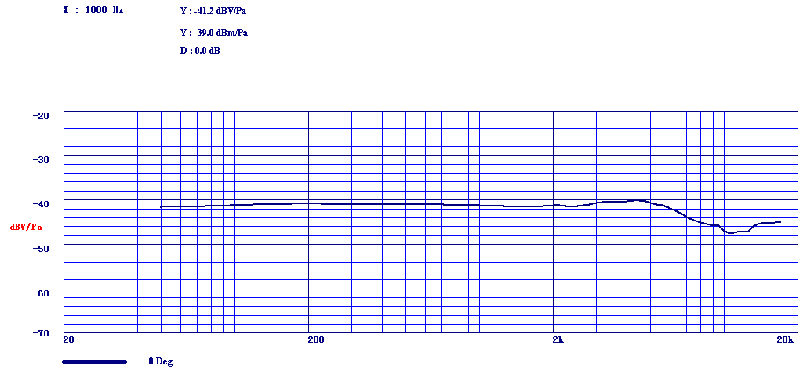
 | 3.10 Microphone Circuit Diagram：
 | 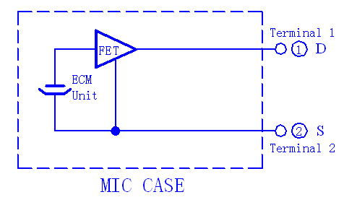
PAGE 3/5
3.11 Schematic Measuring Diagram：
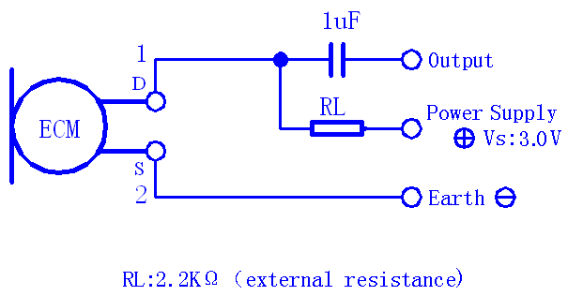
4 Mechanical Specifications：
 | 4.1 | Drawing  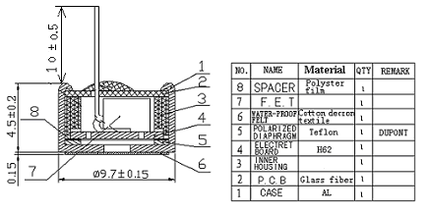
 | 4.2 | Dimension (mm):  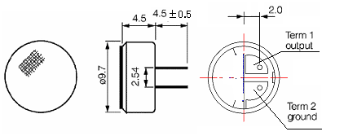
 | 4.3 | Weight | 0.8g
 | 4.4 | Mechanical Intensity | To be no interference in operation after pulled the terminals with 1.0Kg weight for 1 minute.

PAGE 4/5
5.Reliability Tests: After any following tests, the sensitivity of the microphone unit shall not change more than ±3dB from initial value, and shall keep their initial operation and appearance.
 | 5.1 |  | Hi-Temp. Test | The microphone unit must be subjected to +70℃ for 200 Hours, and expose to room temperature for 3 Hours.
 | 5.2 |  | Low-Temp. Test | The microphone unit must be subjected to -25℃ for 200 Hours, and expose to room temperature for 3 Hours.
 | 5.3 |  | Humi.&Heat Test | The microphone unit must be subjected to +60℃, 90% RH-for 200 Hours, and expose to room temp for 3 Hours .
 | 5.4 |  | Humidity Shocking Test | The microphone unit must be subjected to following conditions (+50℃ 1H-room temp 1H;-10℃ 1H-room temp 1H) at 5 cycle, and expose to room temp for 3 Hours.
 | 5.5 |  | Vibration Test | The microphone unit must be subjected to a procedure that after vibrating for two hours from each of the two directions with a frequency of 10-55Hz and a 1.52mm-high amplitude.
 | 5.6 |  | Dropping Test | The microphone unit must be subjected to a procedure that after dropping to a slippery marble floor for 5 times from a 1-meter-high without package.
 | 5.7 |  | ESD Test | The microphone under test must be discharged between each ESD  exposure (contact : ±4KV, air: ±4KV)  There is no interference in operation after 10 times exposure.
6 | Environmental Condition:
 | 6.1 |  | Storage condition | -40℃~+70℃ R.H. less than 90%
 | 6.2 |  | Operation condition | -40℃~+110℃ R.H. less than 90%
 | 6.3 |  | Arbitration  condition | Temperature ：20℃±1℃  Relative humidity：63%~67%  Air pressure ：86~106Kpa
7 | Notices:
 | 7.1 | Always Avoid bringing pinholes on the soldering terminal during the operation to the omi-directional microphones.
 | 7.2 | Operators, the solder fixtures and the soldering irons must be statically grounded under each soldering process.
 | 7.3 | All the soldering procedures upon microphones must be completed in a metallic device, the temperature of the soldering irons must be limited as 320℃±10℃. Soldering time should not exceed 2 Seconds.  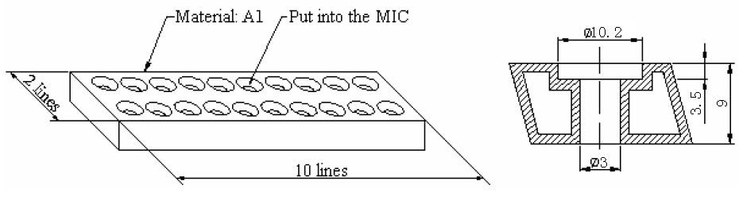

PAGE 5/5
8 | Packing Specification:
 |  | Drawing(Unit: mm) | Qty (pcs.) | Material | Marking
 | Packing | 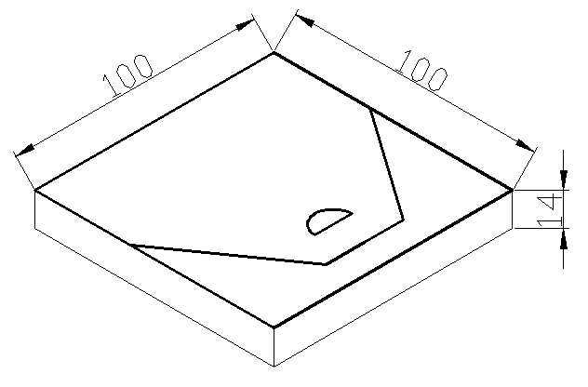 | 100 | Paper
 | Middle  Box | 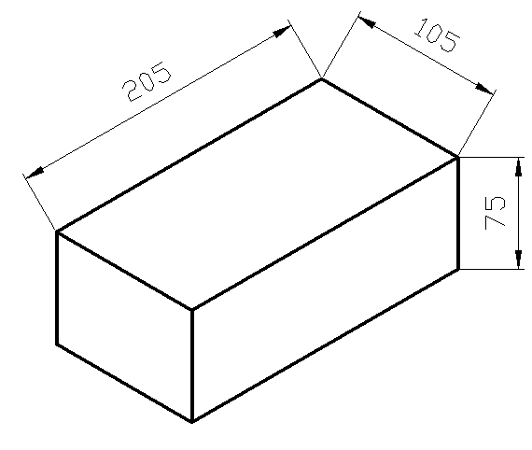 | 10×100 | Paper
 | Outer  Box | 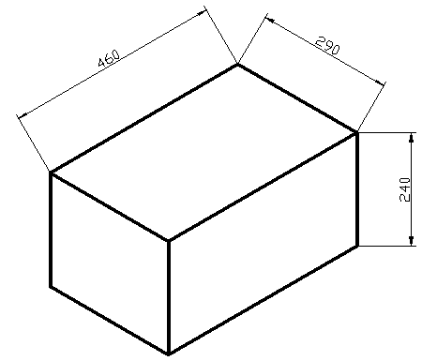 | 20×1000 | Paper | Particular for Customer’s P.O

