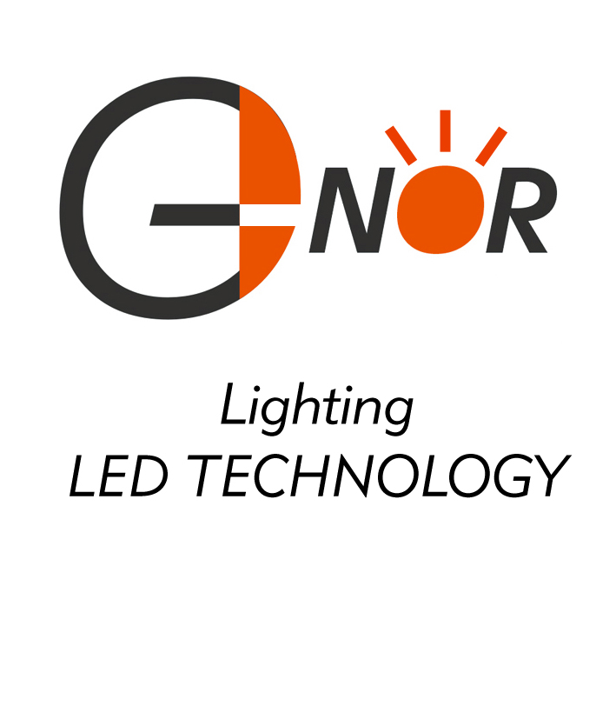
G-NOR ELECTRONICS CO.,LTD.

GNL-3015xx  (Φ3mm ROUND TYPE)  Bi-color series  ABSOLUTE MAXIMUM RATING:(Ta=25℃) | 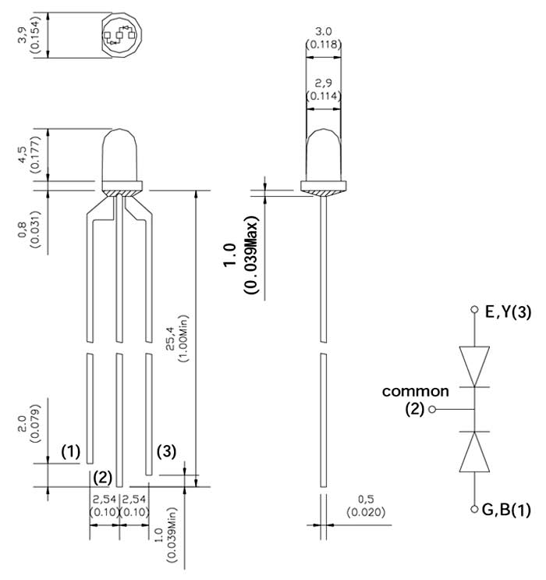
  Parameter |  |  | Unit
  DC Forward Current | 30 |  | mA
  Reverse Voltage | 5 |  | V
  Reverse Current (Vr-5V) | 10 |  | µA
  Peak Forward Current ,tw ,=1 msec Duty ,=1/20 | 150 |  | mA
  Operation Temperature | -40 | +80 | ℃
  Storage Temperature | -40 | +100 | ℃
  Solder Dip Temperature  (5 seconds,1.6mm from body ) | 300 | ±5 | ℃
Part Number | EMITTED COLOR |  | Mix  Emitted  Color | Lens Color | Peak Wave  length  (nm) | Vf  (v)  Typ. | IV (If=20mA) mcd |  | View Angle  2θ1/2
 |  |  |  |  |  |  | Min. | Typ. | View Angle  2θ1/2
GNL-3015EGW | GaAsp/Gap | Hi-Eff Red | Orange | White Diffused | 635 | 2.0 | 8.0 | 15 | 60°
GNL-3015EGW | Gap | Green | Orange | White Diffused | 565 | 2.1 | 5.0 | 10 | 60°
GNL-3015YGW | Gap | Green | Yellow-Green | White Diffused | 565 | 2.1 | 5.0 | 10 | 60°
GNL-3015YGW | GaAsp | Yellow | Yellow-Green | White Diffused | 585 | 2.1 | 5.0 | 10 | 60°
GNL-3015UEUBW | AlGaInP | Super Red | Purple | White Diffused | 625 | 2.0 | 120 | 200 | 60°
GNL-3015UEUBW | InGaN | Super Blue | Purple | White Diffused | 470 | 3.5 | 110 | 180 | 60°
GNL-3015UEUGW | AlGaInP | Super Red | Orange | White Diffused | 625 | 2.0 | 120 | 200 | 60°
GNL-3015UEUGW | AlGaInP | Super Green | Orange | White Diffused | 572 | 2.0 | 100 | 150 | 60°
GNL-3015EGC | GaAsp/Gap | Hi-Eff Red | Orange | Water Clear | 635 | 2.0 | 20 | 40 | 30°
GNL-3015EGC | Gap | Green | Orange | Water Clear | 565 | 2.1 | 15 | 25 | 30°
GNL-3015UYUGC | AlGaInP | Super yellow | Yellow-Green | Water Clear | 590 | 2.1 | 270 | 500 | 30°
GNL-3015UYUGC | AlGaInP | Super Green | Yellow-Green | Water Clear | 572 | 2.1 | 260 | 500 | 30°
GNL-3015UEUGC | AlGaInP | Super Red | Orange | Water Clear | 625 | 2.0 | 280 | 500 | 30°
GNL-3015UEUGC | AlGaInP | Super Green | Orange | Water Clear | 572 | 2.0 | 260 | 350 | 30°
GNL-3015UEUBC | AlGaInP | Super Red | Purple | Water Clear | 625 | 2.0 | 280 | 500 | 30°
GNL-3015UEUBC | InGaN | Super Blue | Purple | Water Clear | 470 | 3.5 | 350 | 450 | 30°

