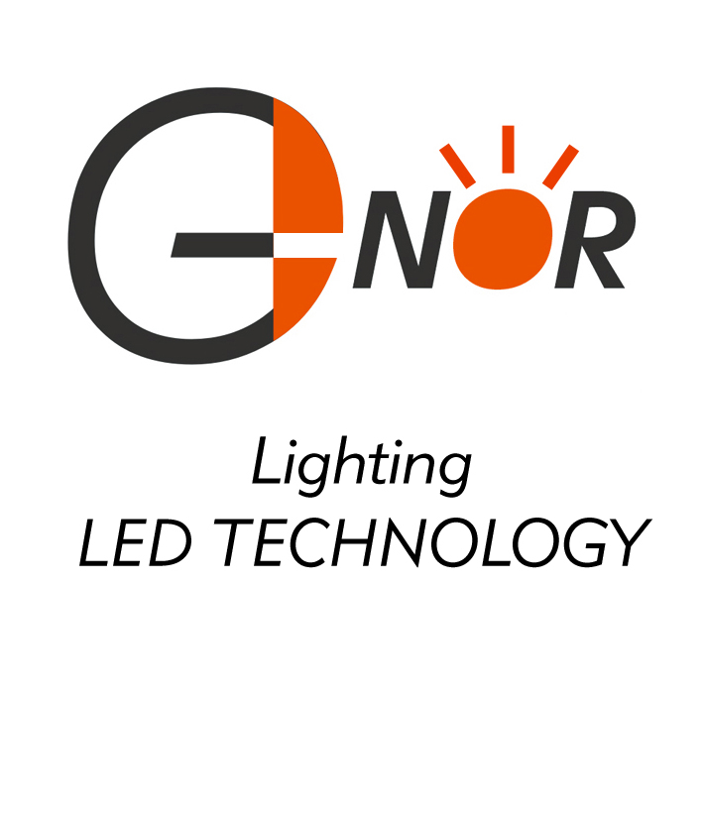
G-NOR ELECTRONICS CO.,LTD.

GNL-1880xx (7.62x7.62)
PIRANHA TYPE

Flux LED Lamp

ABSOLUTE MAXIMUM RATING:(Ta=25℃)
Parameter |  |  | Unit
DC Forward Current | 40 |  | mA
Reverse Voltage | 5 |  | V
Reverse Current (Vr-5V) | 10 |  | µA
Peak Forward Current ,tw ,=1 msec Duty ,=1/20 | 180 |  | mA
Operation Temperature | -40 | +80 | ℃
Storage Temperature | -40 | +100 | ℃
Solder Dip  (5 seconds,1.6mm from body ) Temperature | 300 | ±5 | ℃

Part Number | EMITTED COLOR |  | Lens Color | Peak Wavelength  (nm) | Vf  (v)  Typ. | IV (If=20mA) mcd |  | View  Angle  2θ1/2
 |  |  |  |  |  | Min. | Typ. | View  Angle  2θ1/2
GNL-1880UEC | AlGaInP | Orange Red | Water Clear | 625 | 2.0 | 350 | 450 | 70°
GNL-1880URC | GaAlAs | Pure Red | Water Clear | 660 | 1.9 | 250 | 350 | 70°
GNL-1880UYC | AlGaInP | Yellow | Water Clear | 590 | 2.0 | 350 | 450 | 70°
GNL-1880UEC-TL | AlGaInP | Orange Red | Water Clear | 625 | 2.0 | 800 | 1000 | 70°
GNL-1880UYC-TL | AlGaInP | Yellow | Water Clear | 590 | 2.0 | 1100 | 1300 | 70°
GNL-1880UYOC-TL | AlGaInP | Amber | Water Clear | 610 | 2.0 | 1100 | 1300 | 70°
GNL-1880UBC | InGaN | Blue | Water Clear | 470 | 3.5 | 600 | 800 | 70°
GNL-1880BGC | InGaN | Cyan | Water Clear | 505 | 3.5 | 700 | 900 | 70°
GNL-1880PGC | InGaN | Pure Green | Water Clear | 525 | 3.5 | 1400 | 1800 | 70°
GNL-1880UBC-TL | InGaN | Blue | Water Clear | 470 | 3.5 | 800 | 900 | 70°
GNL-1880BGC-TL | InGaN | Cyan | Water Clear | 505 | 3.5 | 900 | 1100 | 70°
GNL-1880PGC-TL | InGaN | Pure Green | Water Clear | 525 | 3.5 | 3000 | 4000 | 70°
GNL-1880UWC | InGaN | Ultra White | Water Clear | 5500K-7000K | 3.5 | 800 | 1200 | 70°
GNL-1880UWC-15C | InGaN | Ultra White | Water Clear | 5500K-7000K | 3.5 | 1700 | 1900 | 70°
GNL-1880UWC-TL-15C | InGaN | Ultra White | Water Clear | 5500K-7000K | 3.5 | 4000 | 5000 | 90°

