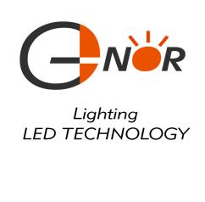

1. NOR ELECTRONICS CO.,LTD.

Lamp Base P/N: B15S/18

Package Dimensions:

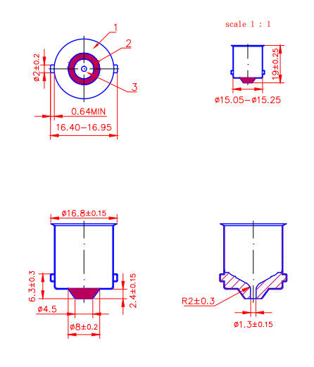

Package Type: 5000PCS / box

Material: Brass / Nickel-Plated