LED Cluster GNCL-R26A5083xx10

Feature:
1)Outdoor Ultra brighter LED cluster
2)Cluster case use black PC plastic waterproof & Anti-aging
3)Lead Wire : 7 X 0.15RV color & black Flat cable. 500mm long.
4)With “EH” Male & Female connector. The pin space of connector is 2.54mm

Electronics Characteristic
LED be used | Forward Voltage (Vf) | Forward Current (If) | Reverse Voltage (VR) | Reverse Current (IR) | Wavelengh (λd) | Intensity  @20mA  per LED | View angle 2θ1/2
GNL-5083UEC-TL | 5.7-6.9V | <40mA | ≧25V | ≦50uA | 625nm±3nm | Typ. 1500mcd | 70±5°
GNL-5083PGC | 6.2-7.0V | <40mA | ≧25V | ≦50uA | 520 nm±5nm | Typ. 2500mcd | 70±5°
The Circuit Drawing as followings:
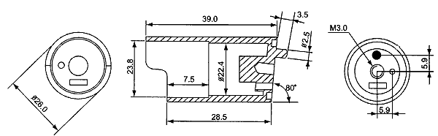
2.54mm pins space
φ26mm
RED wire
500 mm
GREEN wire
Black wire

