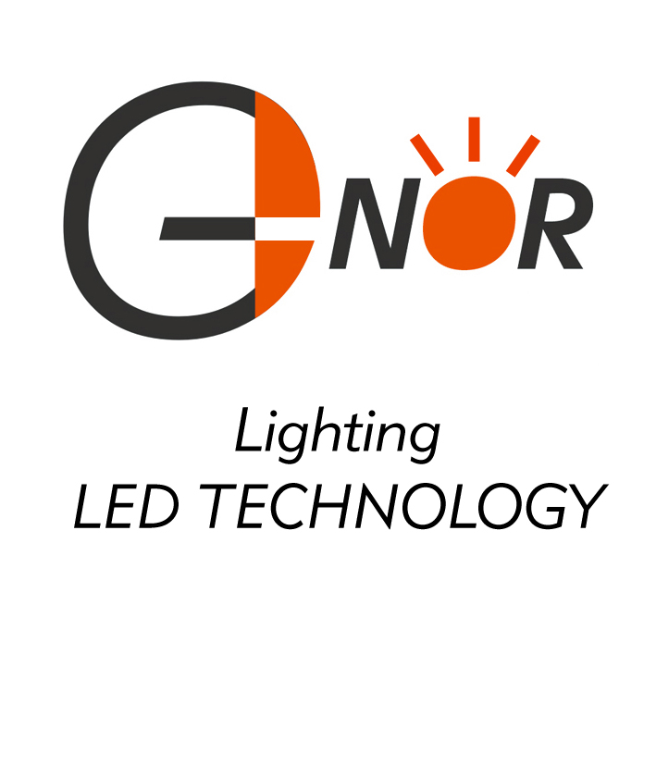

1. NOR ELECTRONICS CO.,LTD.

Lamp Base P/N: S6S/10

Package Dimensions:

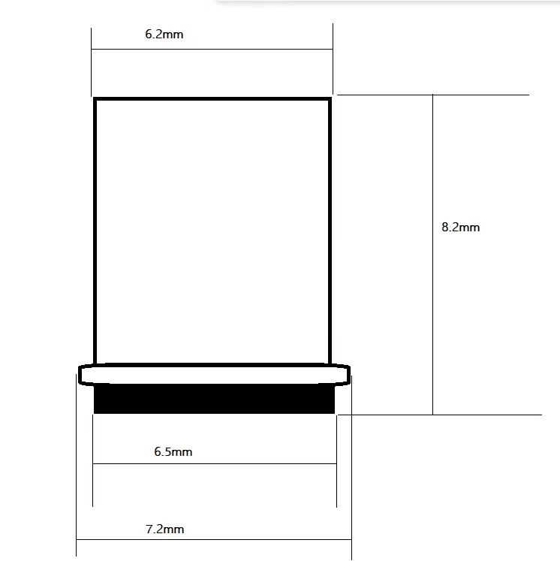

Package Type: 10000PCS / box

Material: Brass / Nickel-Plated

Physical photo：

