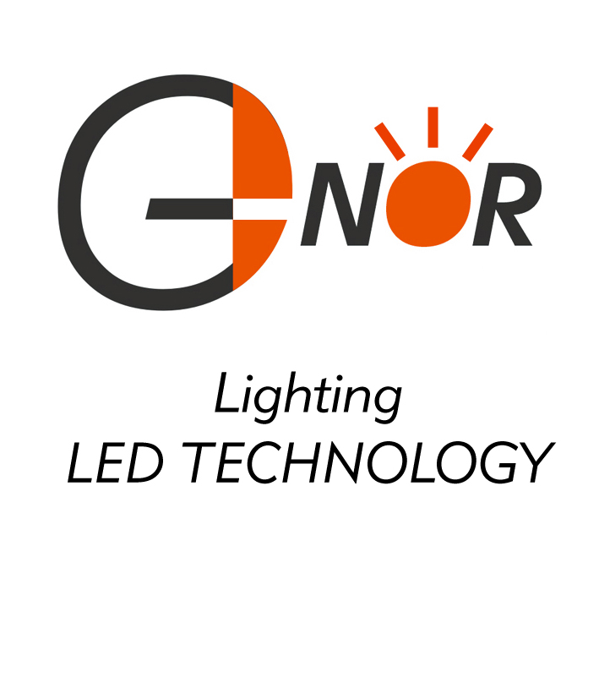
G-NOR ELECTRONICS CO.,LTD.

GNQ-4042Ex-Fx (TRIPLE DIGIT LED DISPLAY)
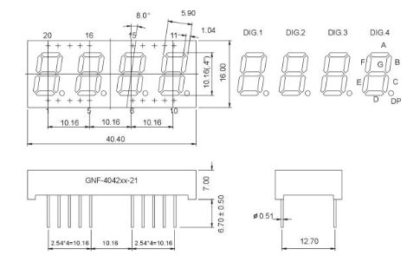
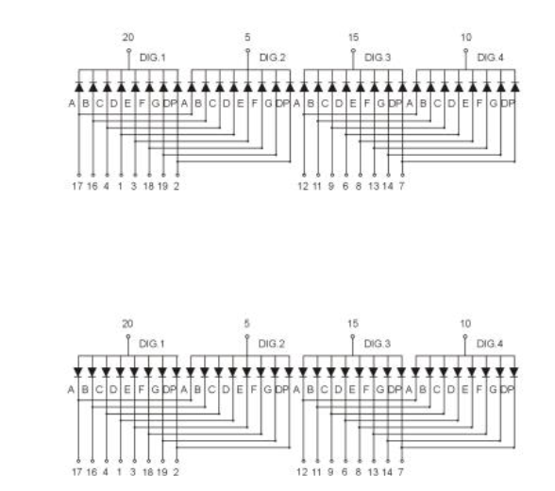
Features:

*0.40 INCH HIGH CHARACTER. *I.C. COMPATIBLE.
*EXCELLENT CHARACTER APPEARANCE. *LOW POWER CONSUMPTION.
*COMMON CATHODE OR COMMON ANODE. *temperature range for GNQ-4042FG： -40 degree /+80 degree

Part Number | EMITTED COLOR |  | Common Cathode  or  Common Anode | Peak Wavelength  (nm) | Vf  (v)  Typ | If  (mA) | Intensity  Per Segment  (mcd)
 |  |  |  |  |  |  | Min. | Typ.
GNQ-4042EE | GaAsP/GaP | Hi.effi Red | Common  Cathode | 635 | 10-20 | 20 | 9 | 12
GNQ-4042EG | GaP | Green | Common  Cathode | 565 | 10-20 | 20 | 8 | 11
GNQ-4042EY | GaAsP/GaP | Yellow | Common  Cathode | 585 | 10-20 | 20 | 9 | 12
GNQ-4042ES | GaAlAs | Super Red | Common  Cathode | 660 | 10-20 | 20 | 10 | 13
GNQ-4042ED | GaAlAs | Ultra Red | Common  Cathode | 660 | 10-20 | 20 | 25 | 30
GNQ-4042EUE | AlGalnP | Ultra Red | Common  Cathode | 625 | 10-20 | 20 | 30 | 35
GNQ-4042EUY | AlGalnP | Ultra Yellow | Common  Cathode | 590 | 10-20 | 20 | 30 | 35
GNQ-4042FE | GaAsP/GaP | Hi.effi Red | Common  Anode | 635 | 10-20 | 20 | 9 | 12
GNQ-4042FG | GaP | Green | Common  Anode | 565 | 10-20 | 20 | 8 | 11
GNQ-4042FY | GaAsP/GaP | Yellow | Common  Anode | 585 | 10-20 | 20 | 9 | 12
GNQ-4042FS | GaAlAs | Super Red | Common  Anode | 660 | 10-20 | 20 | 10 | 13
GNQ-4042FD | GaAlAs | Ultra Red | Common  Anode | 660 | 10-20 | 20 | 25 | 30
GNQ-4042FUE | AlGalnP | Ultra Red | Common  Anode | 625 | 10-20 | 20 | 30 | 35
GNQ-4042FUY | AlGalnP | Ultra Yellow | Common  Anode | 590 | 10-20 | 20 | 30 | 35

