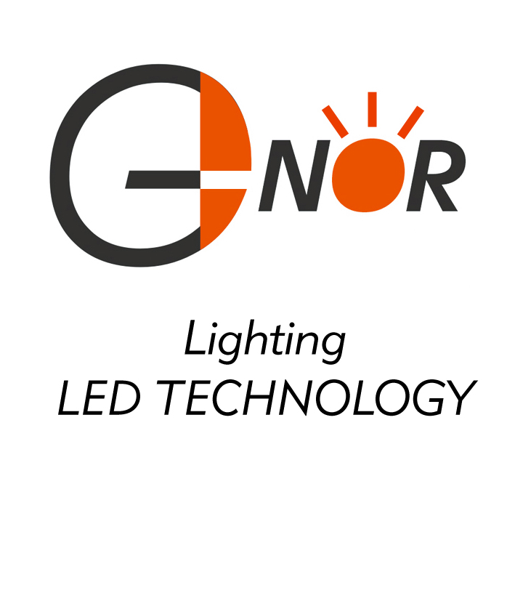
G-NOR ELECTRONICS CO.,LTD.

GNL-5013xx
(Φ5mm ROUND TYPE)
Ultra Brightness

ABSOLUTE MAXIMUM RATING:(Ta=25℃)
Parameter |  |  | Unit
DC Forward Current | 30 |  | mA
Reverse Voltage | 5 |  | V
Reverse Current (Vr-5V) | 10 |  | µA
Peak Forward Current ,tw ,=1 msec Duty ,=1/20 | 150 |  | mA
Operation Temperature | -40 | +80 | ℃
Storage Temperature | -40 | +100 | ℃
Solder Dip  (3 seconds,1.6mm from body ) Temperature | 260 | ±5 | ℃

Part Number | EMITTED COLOR |  | Lens Color | Peak Wavelength  (nm) | Vf  (v)  Typ. | IV (If=20mA) mcd |  | View  Angle  2θ1/2
 |  |  |  |  |  | Min. | Typ. | View  Angle  2θ1/2
GNL-5013SRD | GaAlAs | Super Red | Red Diffused | 660 | 1.9 | 50 | 100 | 60°
GNL-5013SRT | GaAlAs | Super Red | Red Transparent | 660 | 1.9 | 250 | 400 | 18°
GNL-5013SRC | GaAlAs | Super Red | Water Clear | 660 | 1.9 | 250 | 400 | 18°
GNL-5013LRC | GaAlAs | Super Red | Water Clear | 660 | 1.9 | 400 | 500 | 18°
GNL-5013LRD | GaAlAs | Super Red | Red Diffused | 660 | 1.9 | 100 | 150 | 60°
GNL-5013URC | GaAlAs | Super Red | Water Clear | 660 | 1.9 | 600 | 800 | 18°
GNL-5013UEC | AlGaInP | Super Orange Red | Water Clear | 625 | 2.0 | 1200 | 1500 | 18°
GNL-5013HRC | AlGaInP | Super Orange Red | Water Clear | 640 | 2.0 | 500 | 1000 | 18°
GNL-5013HRD | AlGaInP | Super Orange Red | Red Diffused | 640 | 2.0 | 250 | 500 | 60°
GNL-5013GC | GaP | Green | Water Clear | 565 | 2.0 | 40 | 50 | 18°
GNL-5013UGC | AlGaInP | Yellow Green | Water Clear | 572 | 2.0 | 600 | 800 | 18°
GNL-5013UGD | AlGaInP | Yellow Green | Green Diffused | 572 | 2.0 | 150 | 200 | 60°
GNL-5013YC | GaAsP | Yellow | Water Clear | 588 | 2.0 | 40 | 50 | 18°
GNL-5013UYC | AlGaInP | Super Yellow | Water Clear | 590 | 2.0 | 1200 | 1500 | 18°
GNL-5013BC | InGaN | Super Blue | Water Clear | 470 | 3.5 | 1000 | 1500 | 18°
GNL-5013UBC | InGaN | Ultra Super Blue | Water Clear | 470 | 3.5 | 1500 | 2000 | 18°
GNL-5013UBW | InGaN | Ultra Super Blue | Milk Diffused | 470 | 3.5 | 800 | 1500 | 60°
GNL-5013BGC | InGaN | Super Bluish Green | Water Clear | 505 | 3.5 | 4000 | 5000 | 18°
GNL-5013PGC | InGaN | Super Pure Green | Water Clear | 525 | 3.5 | 5000 | 7000 | 18°
GNL-5013VC | InGaN | Super Violet | Water Clear | 395 | 3.5 | 50 | 100 | 18°
GNL-5013UVC | InGaN | Ultra Violet | Water Clear | 270 | 6.0 | 2MW | 3MW | 25°
GNL-5013UEC-1 | AlGaInP | Super Orange Red | Water Clear | 625 | 2.0 | 1000 | 1200 | 18°
GNL-5013UYC-1 | AlGaInP | Super Yellow | Water Clear | 590 | 2.0 | 1000 | 1200 | 18°
GNL-5013PGC-1 | InGaN | Super Pure Green | Water Clear | 525 | 3.5 | 4000 | 5000 | 18°

